PART A
(Part A: TO BE REFERRED BY STUDENTS)
Experiment No. 08
A.1 AIM:
To implement sub queries, set operation and views for solving queries.
A.2 Pre requisite:
Fundamental knowledge of DML instructions and the SQL.
A.3 Outcome:
After successful completion of this experiment students will be able to

- Apply the DML commands on the developed relational models.
- Apply knowledge of relational algebra and structural query language to retrieve and manage data in relational databases.

A.4 Theory:
Sub Queries:
Up to now we have only concentrated on simple comparison conditions in a where clause, i.e., we have compared a column with a constant or we have compared two columns. As we have already seen for the insert statement, queries can be used for assignments to columns. A query result can also be used in a condition of a where clause. In such a case the query is called a subquery and the complete select statement is called a nested query.
In a where clause conditions using subqueries can be combined arbitrarily by using the logical connectives AND and OR.

Example: List the name and salary of employees of the department 20 who are leading a project that started before December 31, 1990:
select ENAME, SAL from EMP where EMPNO in (select PMGR from PROJECT where PSTART < ’31-DEC-90’) and DEPTNO =20;
Explanation: The subquery retrieves the set of those employees who manage a project that started before December 31, 1990. If the employee working in department 20 is contained in this set (in operator), this tuple belongs to the query result set.

select * from EMP where DEPTNO in (select DEPTNO from DEPT where LOC = ’BOSTON’);
The subquery retrieves only one value (the number of the department located in Boston). Thus it is possible to use “=” instead of in. As long as the result of a subquery is not known in advance, i.e., whether it is a single value or a set, it is advisable to use the in operator.
Conditions of the form <expression> <comparison operator> [any|all] <subquery> are used to compare a given <expression> with each value selected by <subquery>.

- For the clause any, the condition evaluates to true if there exists at least on row selected by the subquery for which the comparison holds. If the subquery yields an empty result set, the condition is not satisfied.
- For the clause all, in contrast, the condition evaluates to true if for all rows selected by the subquery the comparison holds. In this case the condition evaluates to true if the subquery does not yield any row or value.

Example: Retrieve all employees who are working in department 10 and who earn at least as much as any (i.e., at least one) employee working in department 30:
select * from EMP where SAL >= any (select SAL from EMP where DEPTNO = 30) and DEPTNO = 10;
Note: Also in this subquery no aliases are necessary since the columns refer to the innermost from clause.
Example: List all employees who are not working in department 30 and who earn more than all employees working in department 30:

select * from EMP where SAL > all (select SAL from EMP where DEPTNO = 30) and DEPTNO <> 30;

SET OPERATION
According to SQL Standard there are following Set operator types:
- Minus
- Intersect All
- Intersect [DISTINCT];
- Union All;
- Union [DISTINCT];

Some facts:
  - UNION and INTERSECT operators are commutative, i.e. the order of queries is not important; it doesn't change the final result.
  - Minus operator is NOT commutative, it IS important which query is first, which second using Minus operator.
  - UNION, Minus and INTERSECT used without anything or with DISTINCT returns only unique values. This is especially interesting when one query returning many nonunique rows is UNIONED to another query returning zero rows. The final result contains fewer rows than first query.
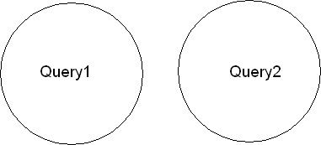
These usually are most widely used set operators. Quite many times one cannot get all the result from one Select statement. Then one of the UNIONS can help. Graphically UNION can be visualised using Venn diagrams. Assume we have two row sets.

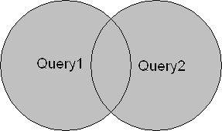
Then Query1 UNION Query2 would be as follows. Grey area shows resultant set.
Example of Union:
ID | Name
2 | Adam
3 | Chirag
ID | Name
1 | John
2 | adam
The First table, The Second table,

Union SQL query will be:

select * from First UNION select * from second

ID | Name
1 | John
2 | Adam
3 | Chirag
The result table will be:

Union All:
This operation is similar to Union. But it also shows the duplicate rows. For above tables, Union all will be:
ID | Name
1 | John
2 | Adam
2 | Adam
3 | Chirag

select * from First UNION ALL select * from second The result table will be:

Intersect:
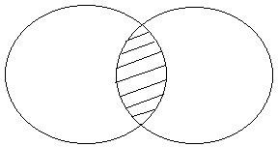
Intersect operation is used to combine two SELECT statements, but it only returns the records which are common from both SELECT statements. In case of Intersect the number of columns and data type must be same.
For the given above tables (In example of Union), intersect query will be:
select * from First INTERSECT select * from second
The result table will be as below:

ID | Name
2 | Adam

Minus:
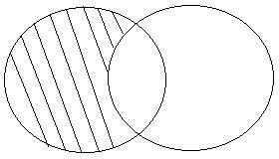
Minus operation combines result of two Select statements and return only those results which belong to first set of result.

For the above tables (given in example of Union), Minus query will be:
select * from First MINUS select * from second
The result table will be:

ID | Name
1 | John

Views:
After a table is created, it may become necessary to prevent all users from accessing all columns of a table, for data security reasons. This would mean creating several tables having the appropriate number of columns and assigning specific users to each table as required. But this will increase redundancy. To reduce redundant data, SQL allows the creation of an object called a view. A view takes the output of a query and treats it as a table, therefore view can be thought of as a ‘stored query’ or a ‘virtual table’. The tables upon which views are based are known as base tables.
The syntax for creating a view:
create [or replace][no][force]view <viewname>[column alias name] as <query>[with check option][read only][constraint];
  - Or replace – replaces an existing view with the same name, if it already exists
  - The force option- creates a view even though underlying table does not exist.
  - The column alias are used for the columns selected by the sub-query.
  - With read only – is to make sure that the data in the underlying table are not changed.
Example:

create view emp_vw as select * from emp;
Suppose we want to create view on employee table to see only employees of department 10, view can be written as:

create view emp_vw_dept as select & from emp where dept_no=10;
If we don’ t want user to update data of table through views, we can create read only views as below:
create or replace emp_vw as select * from emp with read only;
If we now fire query as below then it will give an error:

update emp_vw set sal=10000 where empno=7456;

  - Task: For given tables solve below queries:
category_header
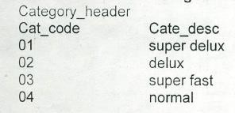
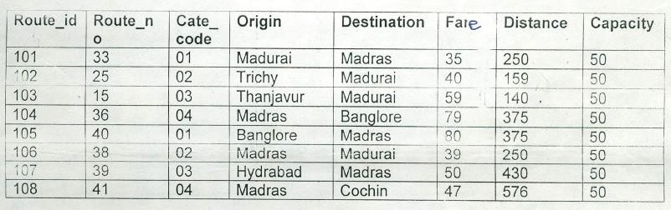
route_Header

Place Header:
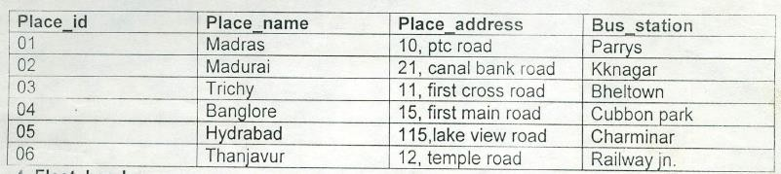
Fleet Header:
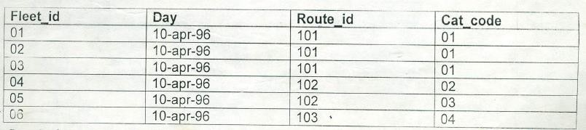
Ticket Header:
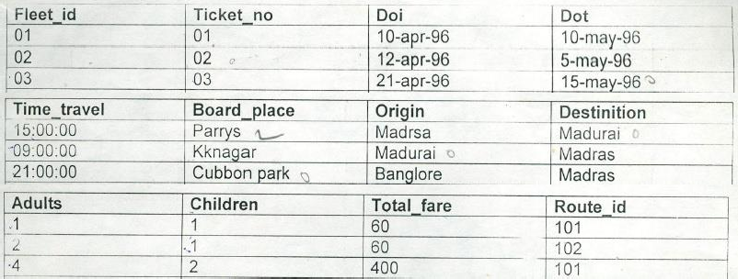
Ticket Detail:
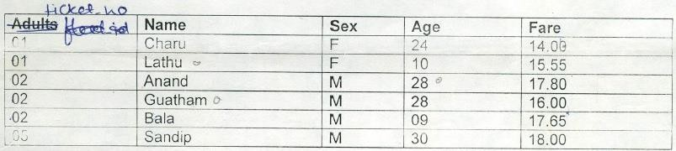
Route Detail:
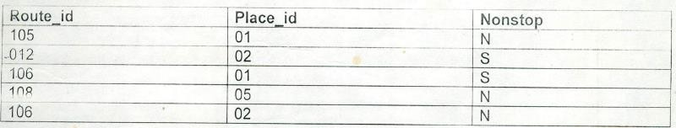
Queries:

  - Find out place names for which nonstop buses run.
  - Find out details of tickets from ticket header having more than two passengers.
  - Find out details of route having category code same as category code of a route having maximum distance.
  - Display distinct ticket number from both ticket_header and ticket_detail.
  - Display all ticket numbers from both ticket_header and ticket_detail.
  - Display only common fleet_id’s that are present in fleet_header and ticket_header.
  - Select distinct route_id from route_header and not in route_detail using both the tables.
  - Display distinct route_id’s from route header and route_detail.
  - Display all category_code from route_header and category_header.
  - Display only common place_id’s that are present in place_header and route_detail.
  - Select common ticket_numbers from ticket_header and ticket_detail where the route_id’s are smaller than the route_id which belong to place id as 01.
  - Select unique fleet_id’s from ticket_header and fleet_header where the route_id is greater than route_id’s in route_header which belongs to the category_code as 01.
  - Create read only view route_vw on table route_header to display route_id, origin and destination.
  - Try to update any record of view route_vw and explain error message.
  - Create view route_vw2 on table route_header with columns route_no, cat_code, orgin and destination.
  - Display records of view route_vw2.
  - Try to insert record into view route_vw2 and state the output if possible else explain error message.
  - Create view route_category_vw to display those routes which belong to category ‘delux’.

PART B
(PART B: TO BE COMPLETED BY STUDENTS)
(Students must submit the soft copy as per following segments within two hours of the practical. The soft copy must be uploaded on the Blackboard or emailed to the concerned lab in charge faculties at the end of the practical in case the there is no Black board access available)
Roll No. : C172 | Name: parva gaglani
Class : D | Batch : d2
Date of Experiment : | Date/Time of Submission : 31/3/26
Grade :

B.1 Tasks given in PART A to be completed here
(Paste your answers and output here)
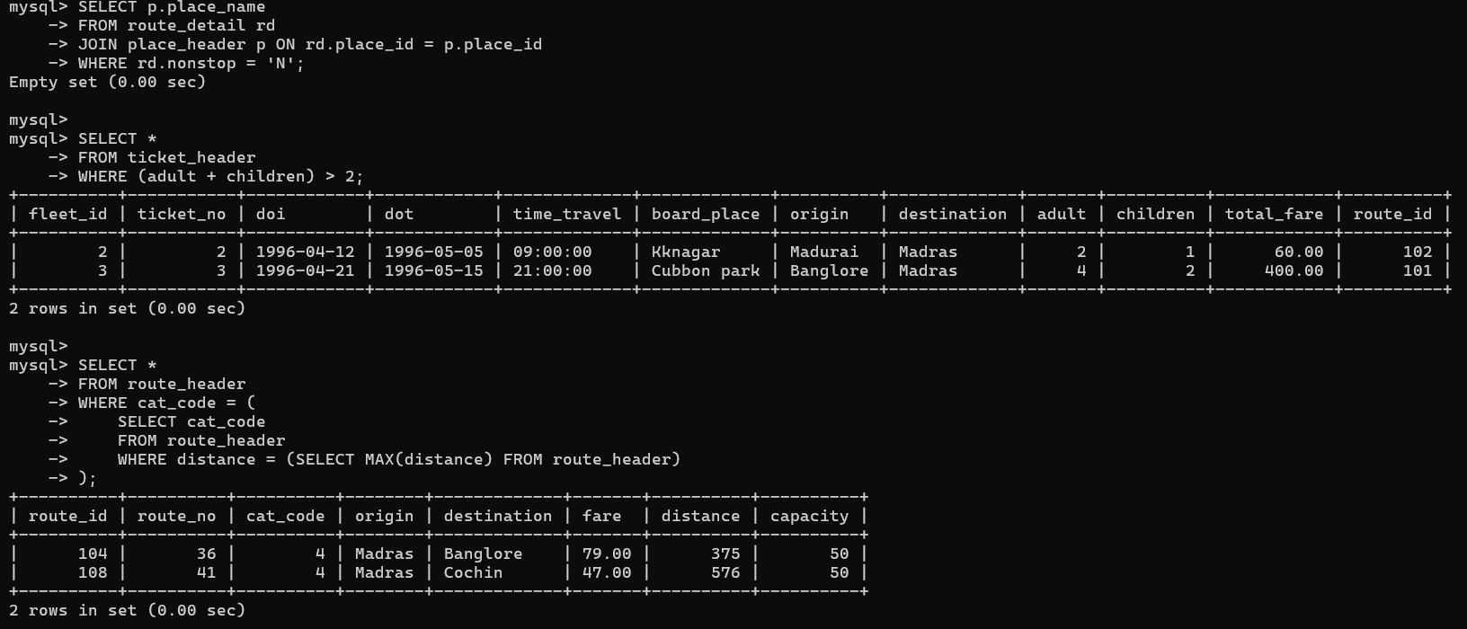
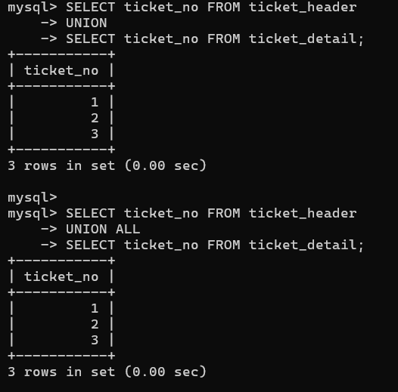
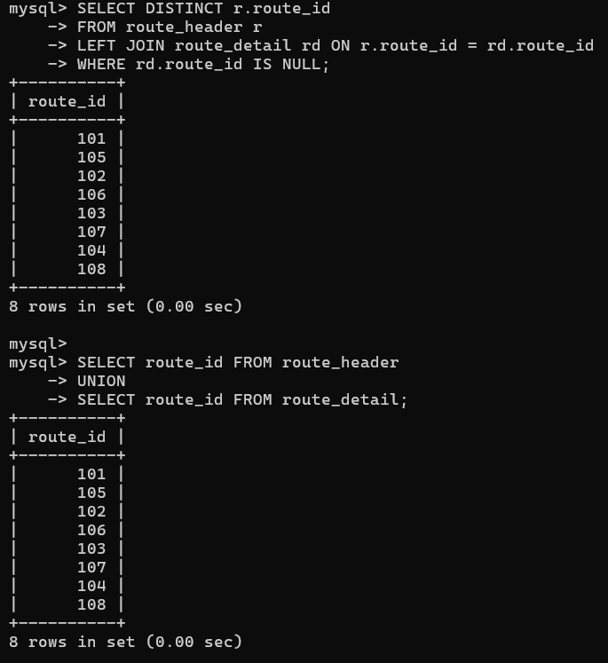
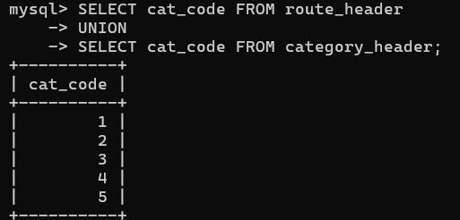’
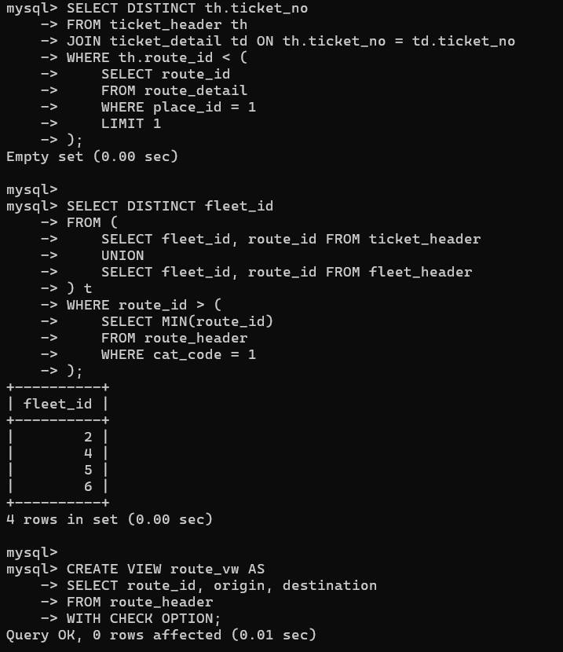
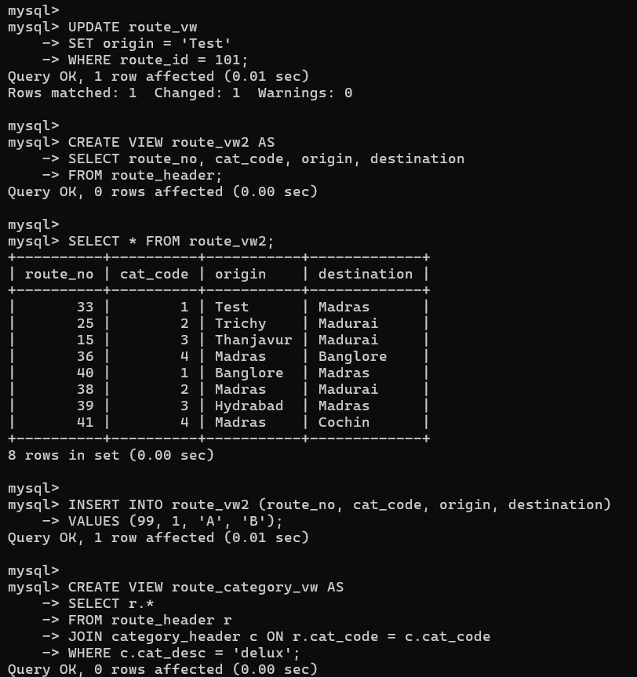
B.2 Conclusion:
(Students must write the observations and learning based on their understanding built about the subject matter and inferences drawn)
I learnt sql commands
B.3 Question of Curiosity
(To be answered by student based on the practical performed and learning/observations)
- Solve below queries for given tables:

Distributor (Dno, Dname, Daddress, Dphone)
Item (Itemno, Itemname, Colour, Weight) Dist_Item (Dno, Itemno, Qty)

- Find distributor who has never supplied any item (using sub query).

- Justify the statement, “Views can be used for better manipulation of the given table”

- Differentiate between ‘Union and ‘Union All’ used for Databases.

- Explain at least one real life Application of views to solve any real-life problem.

Solutions:

1(a). Find distributors who have never supplied any item (using subquery)
You can use a subquery with NOT IN or NOT EXISTS.
Using NOT IN:
SELECT Dno, Dname, Daddress, Dphone
FROM Distributor
WHERE Dno NOT IN (
SELECT Dno FROM Dist_Item
);
Using NOT EXISTS (preferred in many cases):
SELECT Dno, Dname, Daddress, Dphone
FROM Distributor d
WHERE NOT EXISTS (
SELECT *
FROM Dist_Item di
WHERE di.Dno = d.Dno
);

2. Justify: “Views can be used for better manipulation of the given table”
The statement is true, because views improve how we interact with data:
- Simplification: Views allow complex queries (joins, conditions) to be stored and reused as a simple virtual table.
- Security: Users can access only specific columns/rows instead of the full table.
- Data abstraction: Hides underlying table structure from users.
- Consistency: Same query logic reused without rewriting.
- Logical data independence: Changes in base tables often don’t affect views.
👉 Example: Instead of repeatedly joining Distributor and Dist_Item, you can create a view and query it directly.

3. Difference between UNION and UNION ALL
Feature | UNION | UNION ALL
Duplicate rows | Removes duplicates | Keeps duplicates
Performance | Slower (due to duplicate check) | Faster
Result set | Unique rows only | All rows included
Use case | When distinct results are needed | When duplicates are acceptable
Example:
SELECT Itemname FROM Item
UNION
SELECT Itemname FROM Dist_Item;
SELECT Itemname FROM Item
UNION ALL
SELECT Itemname FROM Dist_Item;

4. Real-life application of Views
Scenario: Banking System
A bank database has a table:
Customer (CustID, Name, Address, Balance, AccountType)
Problem: Employees should not see sensitive data like full balance details.
Solution using a View:
CREATE VIEW Customer_Public AS
SELECT CustID, Name, AccountType
FROM Customer;
Benefits:
- Employees can only access limited data.
- Sensitive fields (like balance) are hidden.
- Improves security and data privacy.
Real-life use:
- Used in banking, hospitals, e-commerce to restrict sensitive data.
- Example: A hospital view may hide patient diagnosis from non-medical staff.

